When I load your program file, this window pups up. I clicked on No.
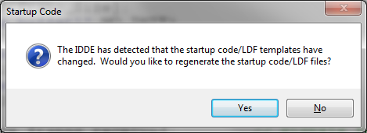

Memory mapping for bank0, 1, 2, 3 < 0x4000000, all SDRAM work.
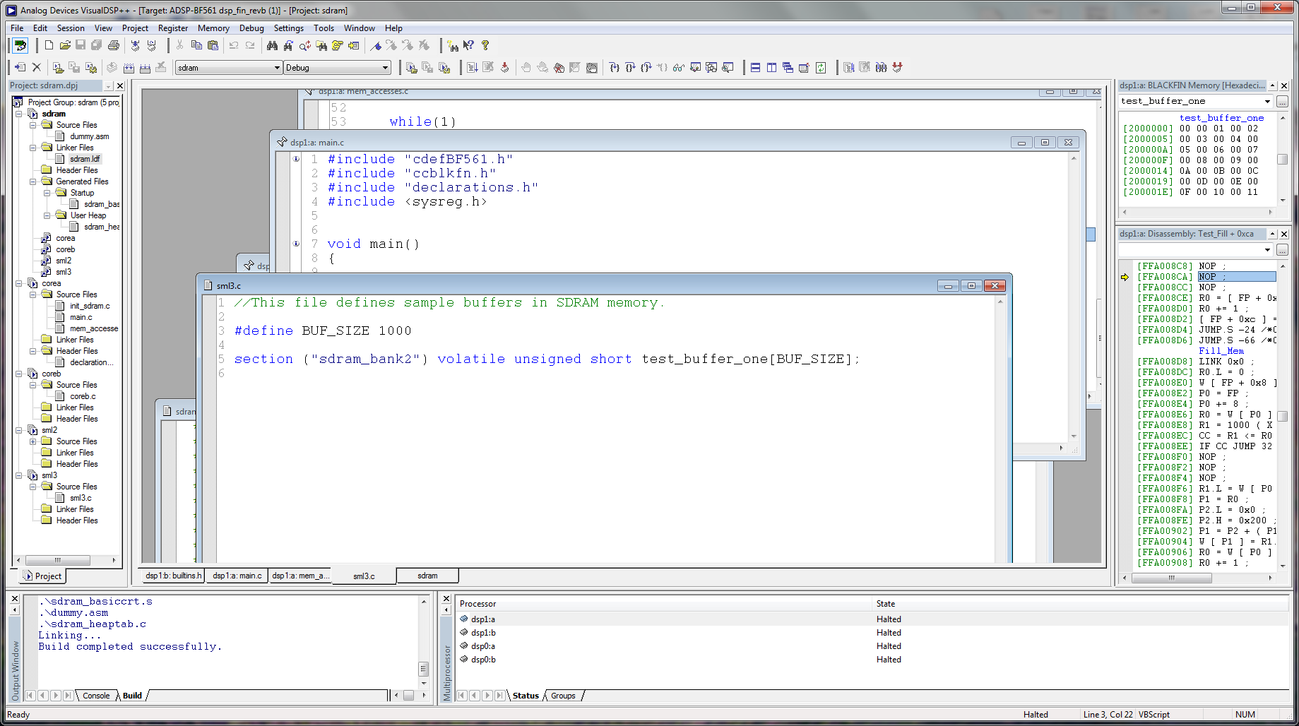
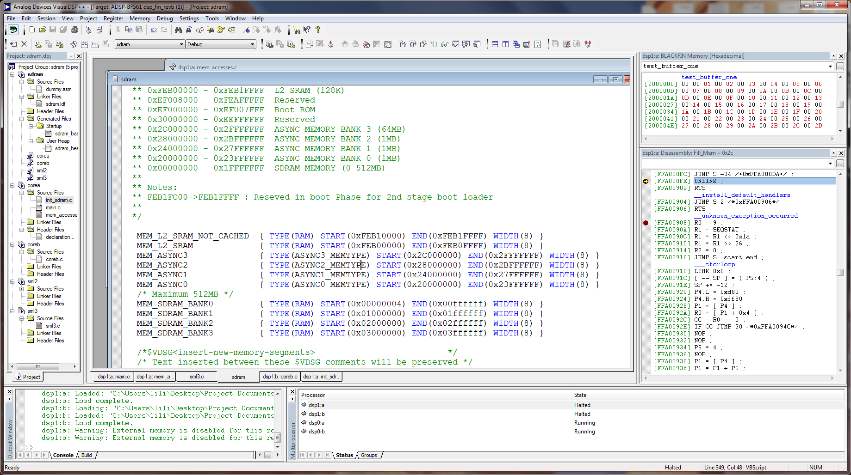
SDRAM map is smaller than 0x4000000 H

Sdram is larger than 0x4000000H, bank1, 2, and 3 are not enabled. Bank1, band2 and bank3’s value are all equal to 0xDD. See screen shots.

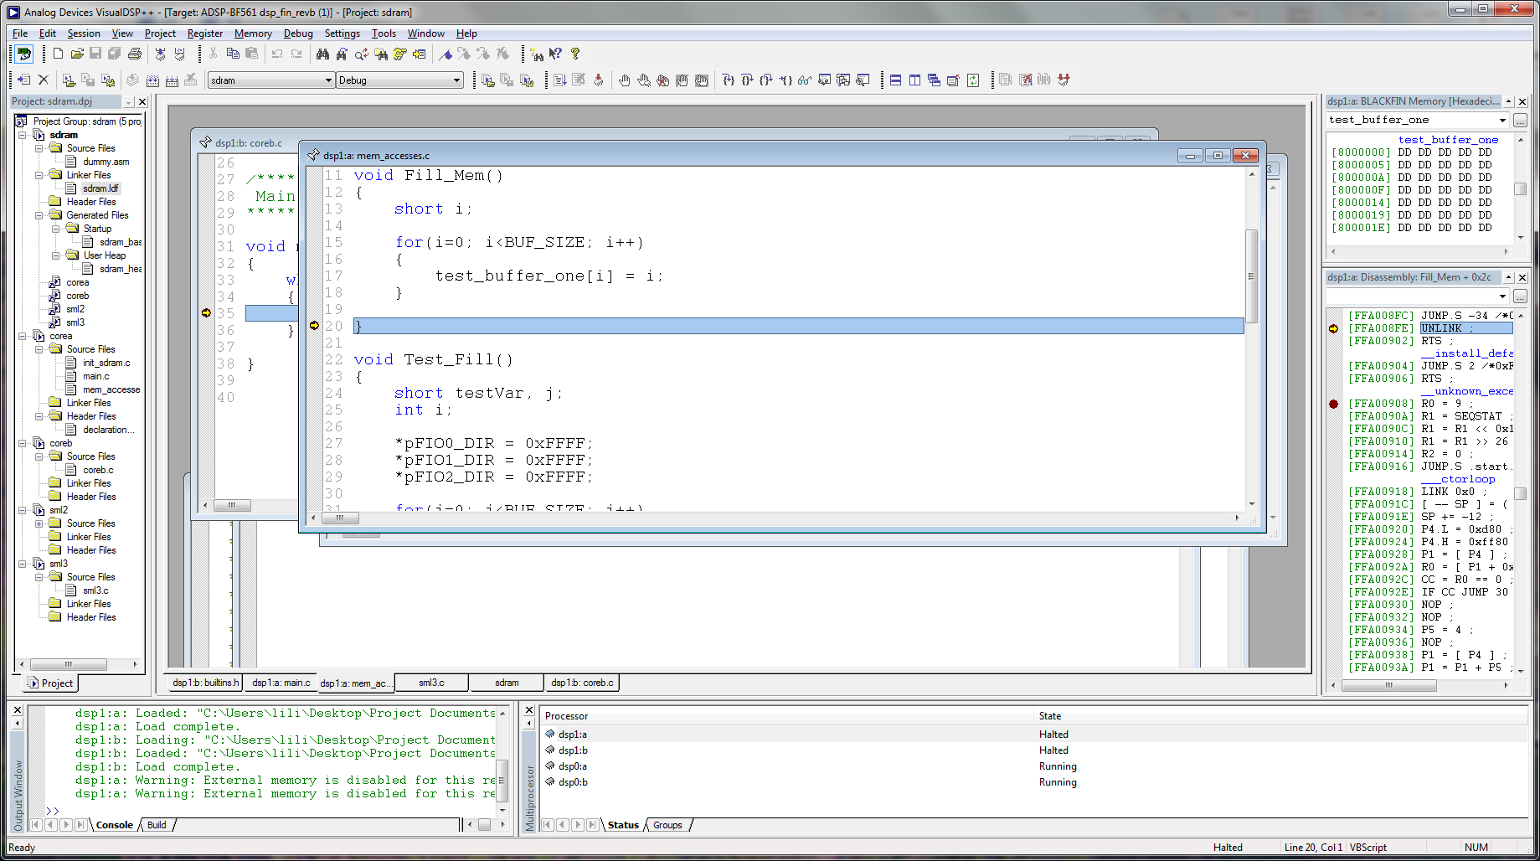

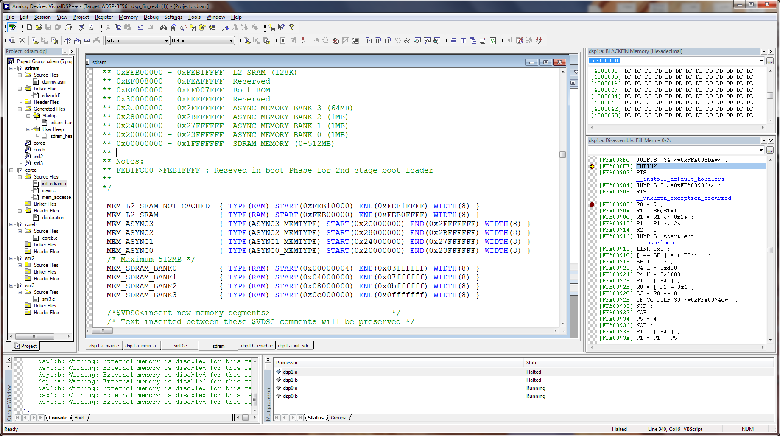
SDRAM map is passed section 0x4000000

